 | Departamento: Ingeniería e Investigaciones Tecnológicas  Carrera: Tecnicatura en Desarrollo Web  Materia: Taller Práctico Integrador  Docentes: Ing. Cintia V. Gioia / Ing. Gerardo Barbosa

Deukin
Sistema integral de gestión Académica
Arquitectura del Sistema

Diciembre /2013

Control de Versiones
Identificación del Documento
Tipo | Arquitectura del Sistema
Documento | Deukin – Arquitectura del Sistema
Versión | 1.0

Control de Versiones
Versión | Autor/Autores | Fecha |  | Motivo
1.0 | Alejando Fichera, Juan Diego Margenats | 08/12/2013 |  | Versión Inicial7/11/2026

Índice
I - Introducción 3
II - Caracteríscas Y OBJETIVOS de la Arquitectura 3
III - Requerimientos de software 4
IV - Convenciones Utilizadas 7
V - REPOSITORIO DE VERSIONES 7
VI - entorno de desarrollo 7

Introducción
En el presente documento se detalla la arquitectura de software utilizada para Deukin, los componentes utilizados, frameworks y otras herramientas de utilidad.
Está dirigido al técnico/desarrollador del sistema a fin de tener una visión general del proyecto de software para sus futuras modificaciones y/o mantenimiento.

Caracteríscas Y OBJETIVOS de la Arquitectura
Los objetivos de la arquitectura son brindar una solución que destaque las siguientes características:
- Eficiencia
- Mantenible
- Reutilizable
- Escalabilidad
- Usable

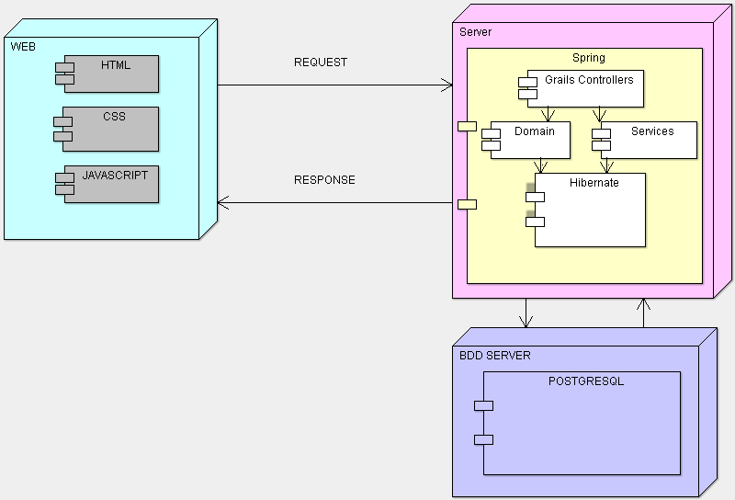

Requerimientos de software
Frameworks Utilizados durante el desarrollo:
Módulo | Revision
liquibase-core by org.liquibase | 2.0.5
jasper by org.grails.plugins | 1.6.1
poi by org.apache.poi | 3.8
jasperreports by net.sf.jasperreports | 4.7.0
itext by com.lowagie | 2.1.7
itext by com.lowagie | 2.1.0
spring-security-ui by org.grails.plugins | 0.2
mysql-connectorj by org.grails.plugins | 5.1.22.1
database-migration by org.grails.plugins | 1.1
yui-minify-resources by org.grails.plugins | 0.1.4
cached-resources by org.grails.plugins | 1.0
zipped-resources by org.grails.plugins | 1.0
resources by org.grails.plugins | 1.1.6
famfamfam by org.grails.plugins | 1.0
jquery-ui by org.grails.plugins | 1.8.7
jquery by org.grails.plugins | 1.8.0
hibernate by org.grails.plugins | 2.2.3
antlr by antlr | 2.7.7
hibernate-ehcache by org.hibernate | 3.6.10.Final
postgresql by postgresql | 9.1-901.jdbc4
jul-to-slf4j by org.slf4j | 1.6.2
log4j by log4j | 1.2.16
ehcache-core by net.sf.ehcache | 2.4.6
xpp3_min by xpp3 | 1.1.4c
h2 by com.h2database | 1.3.164
commons-pool by commons-pool | 1.5.6
commons-dbcp by commons-dbcp | 1.4
commons-fileupload by commons-fileupload | 1.2.2
aspectjrt by org.aspectj | 1.6.10
aspectjweaver by org.aspectj | 1.6.10
rendering by org.grails.plugins | 0.4.4
core-renderer by org.xhtmlrenderer | R8
webflow by org.grails.plugins | 2.0.8.1
hibernate-core by org.hibernate | 3.6.10.Final
cglib by cglib | 2.2
asm by asm | 3.1
hibernate-validator by org.hibernate | 4.1.0.Final
hibernate-commons-annotations by org.hibernate | 3.2.0.Final
ognl by ognl | 2.7.3
spring-webflow by org.springframework.webflow | 2.0.8.RELEASE
spring-js by org.springframework.webflow | 2.0.8.RELEASE
spring-binding by org.springframework.webflow | 2.0.8.RELEASE
asynchronous-mail by org.grails.plugins | 1.0-RC6
quartz by org.grails.plugins | 1.0-RC13
quartz by org.grails.plugins | 1.0-RC10
quartz by org.quartz-scheduler | 2.2.0
slf4j-api by org.slf4j | 1.6.6
slf4j-api by org.slf4j | 1.6.2
richui by org.grails.plugins | 0.8
spring-security-core by org.grails.plugins | 1.2.7.1
spring-security-web by org.springframework.security | 3.0.7.RELEASE
spring-security-core by org.springframework.security | 3.0.7.RELEASE
mail by org.grails.plugins | 1.0.1
spring-test by org.springframework | 3.1.0.RELEASE
mail by javax.mail | 1.4.3
cache by org.grails.plugins | 1.1.1
cache-headers by org.grails.plugins | 1.1.5
grails-datastore-simple by org.grails | 1.1.8.RELEASE
grails-datastore-gorm by org.grails | 1.1.8.RELEASE
grails-datastore-core by org.grails | 1.1.8.RELEASE
jcl-over-slf4j by org.slf4j | 1.6.2
javassist by org.javassist | 3.16.1-GA
spring-webmvc by org.springframework | 3.1.4.RELEASE
dom4j by dom4j | 1.6.1
jstl by javax.servlet | 1.1.2
spring-jms by org.springframework | 3.1.4.RELEASE
spring-aspects by org.springframework | 3.1.4.RELEASE
spring-context-support by org.springframework | 3.1.4.RELEASE
spring-orm by org.springframework | 3.1.4.RELEASE
spring-web by org.springframework | 3.1.4.RELEASE
spring-jdbc by org.springframework | 3.1.4.RELEASE
spring-tx by org.springframework | 3.1.4.RELEASE
spring-context by org.springframework | 3.1.4.RELEASE
spring-expression by org.springframework | 3.1.4.RELEASE
spring-aop by org.springframework | 3.1.4.RELEASE
spring-beans by org.springframework | 3.1.4.RELEASE
spring-core by org.springframework | 3.1.4.RELEASE
spring-asm by org.springframework | 3.1.4.RELEASE
grails-plugin-validation by org.grails | 2.2.3
grails-plugin-url-mappings by org.grails | 2.2.3
grails-plugin-mimetypes by org.grails | 2.2.3
grails-plugin-servlets by org.grails | 2.2.3
grails-plugin-services by org.grails | 2.2.3
grails-plugin-scaffolding by org.grails | 2.2.3
grails-plugin-log4j by org.grails | 2.2.3
grails-plugin-i18n by org.grails | 2.2.3
grails-plugin-gsp by org.grails | 2.2.3
grails-plugin-filters by org.grails | 2.2.3
grails-plugin-datasource by org.grails | 2.2.3
grails-plugin-converters by org.grails | 2.2.3
grails-plugin-domain-class by org.grails | 2.2.3
grails-plugin-controllers by org.grails | 2.2.3
grails-plugin-codecs by org.grails | 2.2.3
grails-logging by org.grails | 2.2.3
grails-web by org.grails | 2.2.3
grails-spring by org.grails | 2.2.3
grails-resources by org.grails | 2.2.3
grails-hibernate by org.grails | 2.2.3
grails-crud by org.grails | 2.2.3
grails-core by org.grails | 2.2.3
grails-bootstrap by org.grails | 2.2.3
sitemesh by opensymphony | 2.4
hibernate-jpa-2.0-api by org.hibernate.javax.persistence | 1.0.1.Final
jta by javax.transaction | 1.1
commons-lang by commons-lang | 2.6
commons-io by commons-io | 2.1
commons-codec by commons-codec | 1.5
concurrentlinkedhashmap-lru by com.googlecode.concurrentlinkedhashmap | 1.3.1
aopalliance by aopalliance | 1.0
commons-validator by commons-validator | 1.3.1
oro by oro | 2.0.8
commons-el by commons-el | 1.0
commons-beanutils by commons-beanutils | 1.8.3
commons-collections by commons-collections | 3.2.1
groovy-all by org.codehaus.groovy | 2.0.8
gpars by org.codehaus.gpars | 1.0.0
jsr166y by org.codehaus.jsr166-mirror | 1.7.0

Convenciones Utilizadas
El lenguaje utilizado es de por sí un lenguaje orientado a las convenciones y buenas prácticas de codificación. Por el momento no existe un documento provisto de convenciones adicional al lenguaje en sí.

REPOSITORIO DE VERSIONES
Deukin posee el código alojado en el servidor de Github. Pudiendo obtener además del fuente otros datos estadísticos, e información referente a cada modificación realizada.
Se puede obtener el mismo desde:

https://github.com/afichera/deukin

El acceso en modo lectura es público, aunque para poder modificar el fuente se requiere un permiso como colaborador.
Teniendo en cuenta que es la primer entrega se trabajó sobre una única rama de código (trunk). Una vez pase a productivo, se deberán abrir nuevas ramas para afrontar los requerimientos.

entorno de desarrollo
Para su desarrollo se requiere tener previamente instalado y configurado:
JDK (Versión 1.7.0_40)
GRAILS (Versión 2.2.3)
Apache Tomcat (Versión 7.0.42)
GitHub Client (cualquier versión compatible con el sitio github.com)
PostqreSQL 9.2

Entorno de Desarrollo Utilizado:
GGTS (Versión 3.3.0)
PGAdmin III
No se requieren configuraciones adicionales para el entorno de desarrollo.

